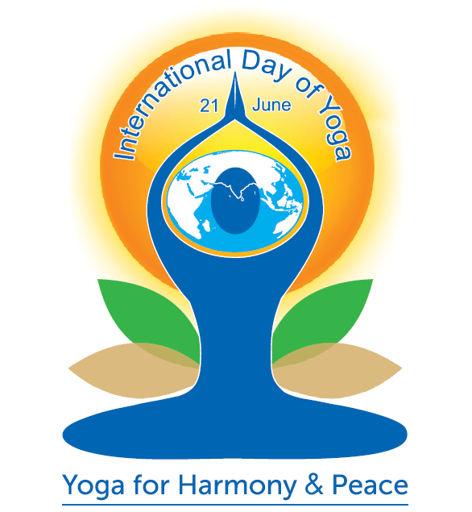 | 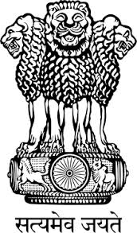 | 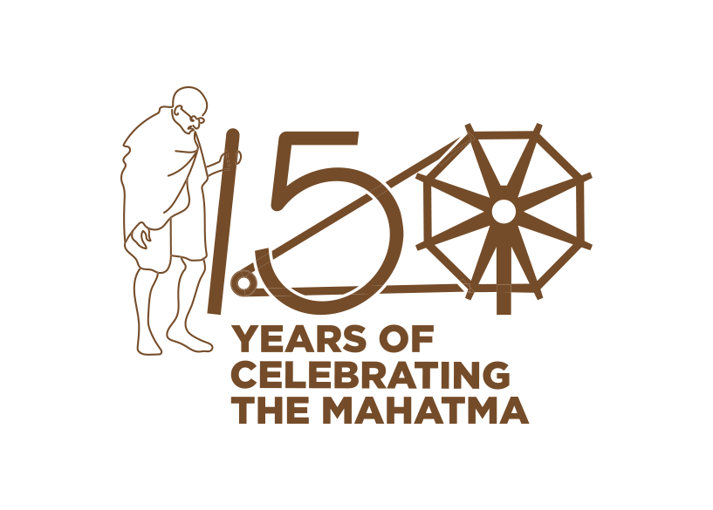
Embassy of India
Kyiv

Press Release for International Day of Yoga

To celebrate the 5th International Day of Yoga, 2019, Embassy of India, Kyiv, in association with Yoga schools and studios based in Ukraine, is organizing a grand “Festival of Yoga” on Saturday, June 22, 2019 at Mariinskyi Park.

The ancient Indian tradition of Yoga is an invaluable gift to humankind, enabling unity of mind and body; thought and action; restraint and fulfillment; and overall well-being. Yoga is not just an exercise, but a journey towards oneness- between Self, Nature, and the World.

Recognizing the immense value of Yoga and its potential to transform human lives, in 2014, United Nations declared June 21 as the “International Day of Yoga” (IDY). The UN Resolution also invites all UN Member States to observe the International Day of Yoga in an appropriate manner in order to raise awareness about the benefits of practicing yoga.

Ukraine is one of the most enthusiastic practitioners of Yoga. There are a number of Yoga schools/studios and practitioners of this ancient discipline in all parts of Ukraine. With assistance of the Ukrainian Federation of Yoga, 5th IDY is also being organized during June 18-23 in over 20 cities of Ukraine.

The June 22 “Festival of Yoga” at Mariinskyi Park will include different Yoga demonstrations and workshops by yoga schools of Kyiv. The day will also be dedicated to diverse aspects of the incredible Indian culture, with presentations of Indian dances, music and art forms. At 17.00 hrs, all enthusiasts and lovers of Yoga would gather together for a combined Yoga exercise. Participants are expected to wear light and comfortable workout clothes and carry a yoga mat with them. On the occasion of the 150th Birth Anniversary of Mahatma Gandhi, a "Vegetarian Food Festival" will also be organized at the venue, to promote Mahatma Gandhi’s message of non-violence.

Entry and participation in the event is free. All are invited to attend the Festival of Yoga and get exposed to the benefits of Yoga/Meditation, and also experience the vibrancy of Indian food and culture.

For regular information about the Festival of Yoga in Kyiv, and Yoga celebrations in other parts of Ukraine, please visit the following links: www.facebook.com/idayofyoga.org.ua/ and www.facebook.com/IndiaInUkraine.

* * *

